Connor O’Brien

Lab 0

September 16, 2021

Computer Science (CS- 151-05)

***PyCharm: Hello There!***

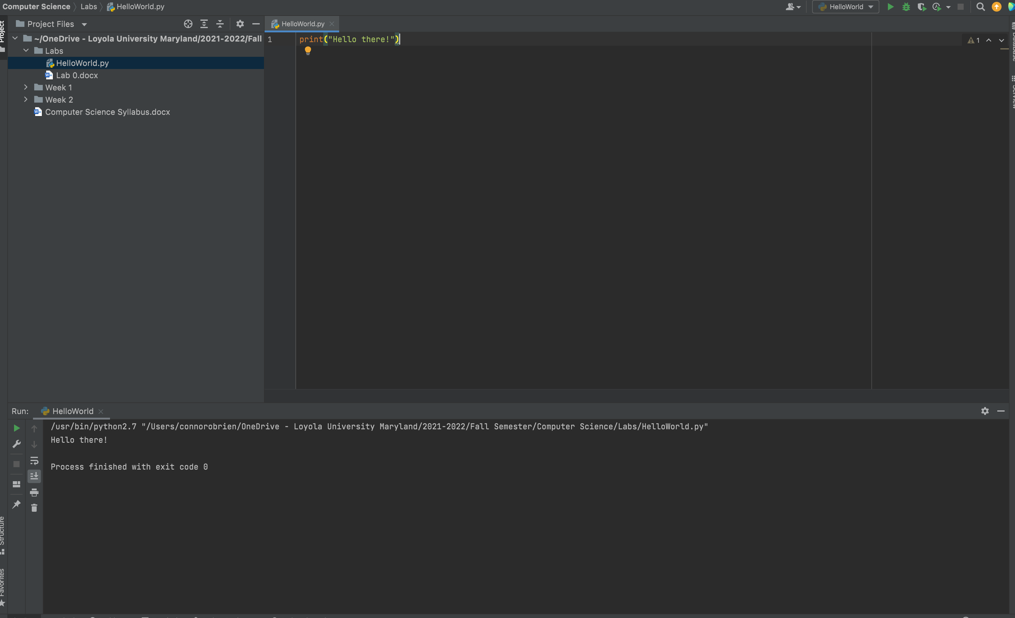

***PyCharm Linked with Github***

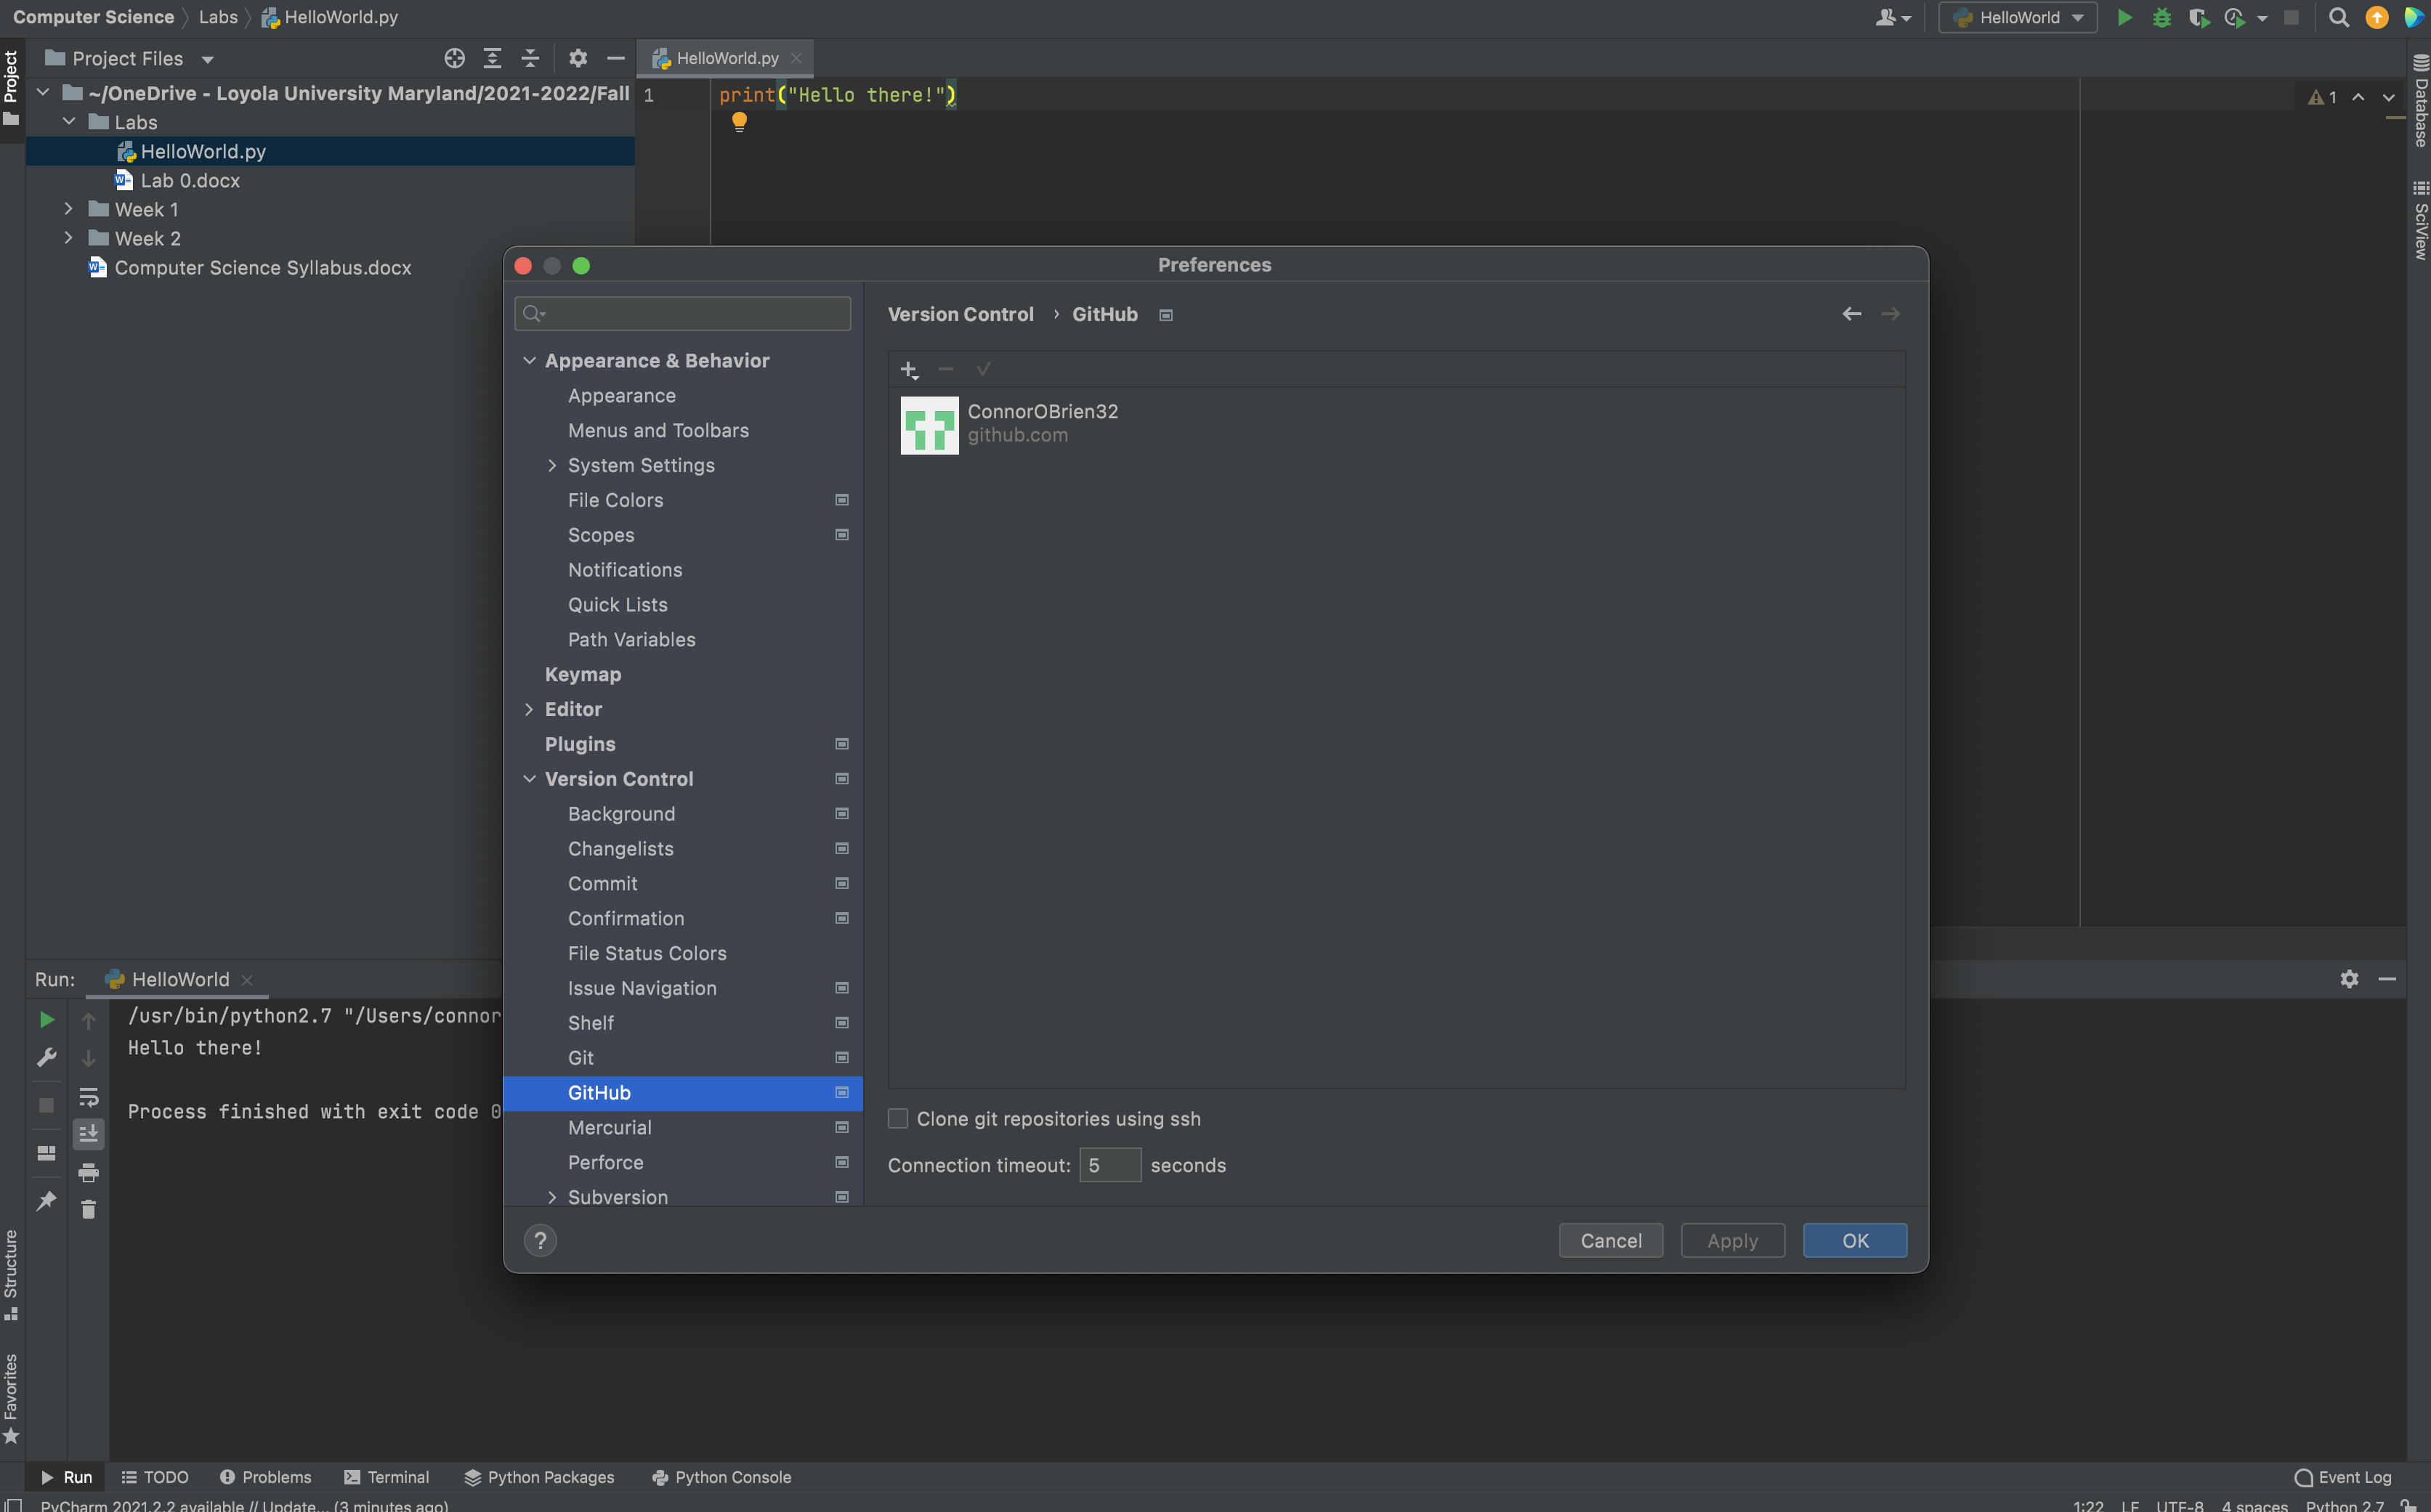

***Python Version 3.8.8***

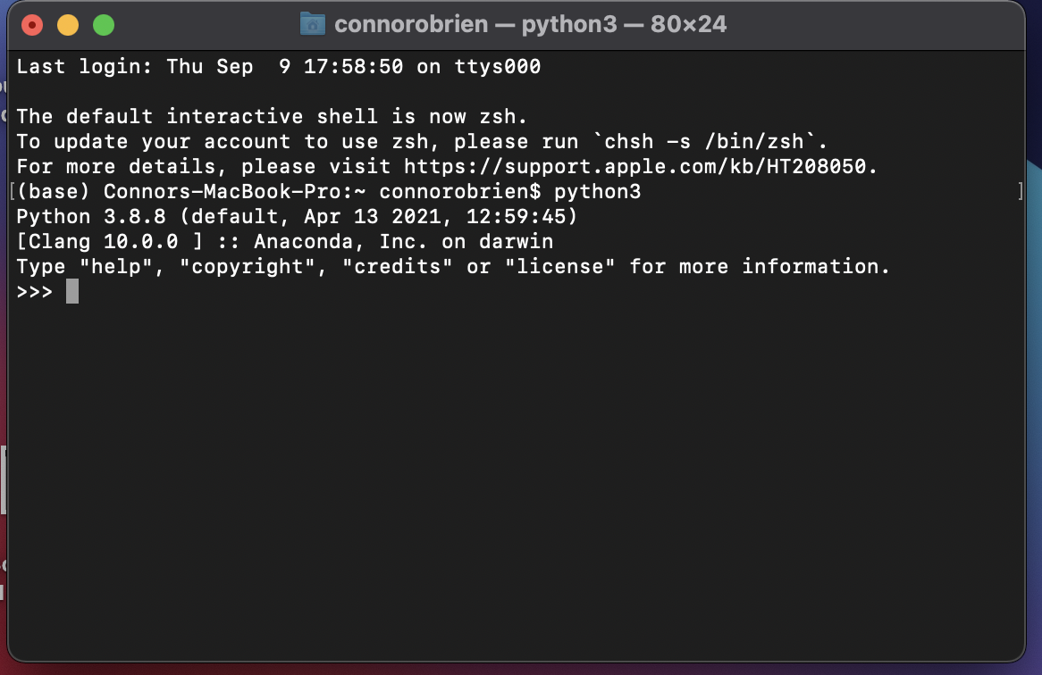

***Github Account Profile***

